KEKS Group/Project Questionnaire  
Staff Instruction

KEKS Group Survey focuses on young people’s experiences of participation and learning in group activities. Through this questionnaire you, as a staff member, will be able to see how, and to which degree, the participants have perceived their participation and if they’ve learned something during the process. No matter the results, there’s always room for improvement!

The results from the separate groups can be viewed at any time in the logbook (as long as you have at least seven respondents). The total result from all the group surveys will be presented in the annual result presentation that comes in December. The group survey is a tool for us in KEKS to develop and improve youth work together.

Step by step – a guide!

1. What is a group?

A ’group’/project can be anything from one young people arranging a happening for his/her friends, or a bigger group which meet once a week and do activities together. It can be a group working in the café at the youth center, a group which have taken part in a youth exchange or a group arranging an event. The questionnaire is not meant for those who are just stopping by the youth center for a visit, or those taking part in some kind of activity. Those visitors should answer the annual meeting place survey and not the group survey.

1. Inform the group about the questionnaire and its purpose

Explain the importance of young people’s participation and learning to the group already when it starts. The questionnaire is meant to make visible what we need to improve. To obtain the input we need, it’s of highest importance that you as staff prepare the young people and speak about the survey in a positive manner. It’s very beneficial to open up for dialogue so that they understand that their views and feedback is of crucial importance for the further development of youth work, and that they must be part of this process.

1. Before the group answers the questionnaire

In order to be able to answer questions that may come up while young people are answering the questionnaire, please read the explanation of the questions carefully before you send out the questionnaire to young people. You will find the explanations in the questionnaire, directly after each question.

1. **Sending out the questionnaire**

The questionnaire should be filled out at most two weeks after finishing the project/group activity. The questionnaire can also be used at the end of each semester for those groups which have continuous activities. When a group is to fill out a questionnaire, you log into the logbook and click the name of the group to reach the link to the questionnaire. After clicking the link, you will be redirected to a page where you can either copy the link to the questionnaire, or fill it out directly.

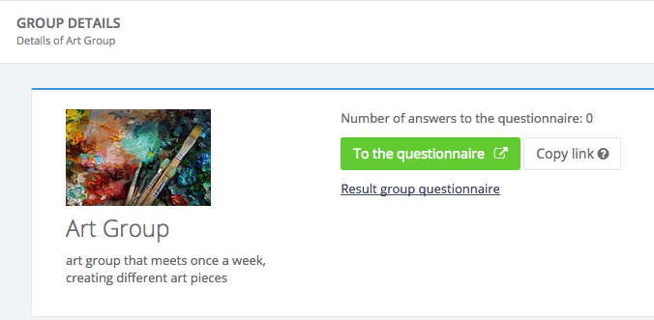

1. When young people are to answer the questionnaire

Inform them about the questionnaire, and tell them:

* That it is completely anonymous, that nobody can see their answers
* That they should relax and think carefully about their answers
* That they should read the explanation that comes in direct connection to each question
* That you are available, should they have any questions

You should provide young people with a space where they can fill out the questionnaire without being disturbed or having their answers overlooked by someone else. A staff member should therefore always keep the space under supervision and be available, should any questions arise.

1. Group questionnaire on paper

Filling out a printed copy of the questionnaire could be better if you think that someone needs support in reading/understanding the questions, or otherwise won’t answer all the questions. If you choose to let someone fill out the paper copy, you will have to fill out all the answers through the web-link in the logbook yourself. If so, be aware of the “skip-logic” in the system, and that some young people might have answered questions, e.g. about school results, that they would not have got if answering on the web.

For the paper copy, the following also applies:

You as staff will fill out the first page before you hand out the questionnaire. When the young person has filled out the survey they should put it in a special box that is set aside for this purpose, or in a big envelope so that they feel assured that no one will be able to see their answers.

1. Feedback and analysis

The Logbook allows you to see how many in the group that have filled out the questionnaire. Once you see that everyone has filled it out, it’s time for some analysis and feedback with the young people. This should be viewed as a chance for mutual learning and an opportunity to improve the next group project or activity. It’s of highest importance that you as a youth worker have a positive and open dialogue about how you can improve yourself and the organisation, so that the conditions for learning and participation become even better.

Good luck, and please let us know if you have any questions!

Kind regards,

Mia, Sara and Jonas

[**info@keks.se**](mailto:info@keks.se)